|  |  |
| --- | --- |
| Course Name | ITD 2313 – Script Programming |
| Instructor | Mark L. Pranger |
| Student Name | Thomas Webb |
| Due date | 5/20/2025 |
| Grade | Put grade earned here |
| Grading Comments | Put instructor comments here |

**Project 1**

**The code SSS**

**Project 7**

**The code**

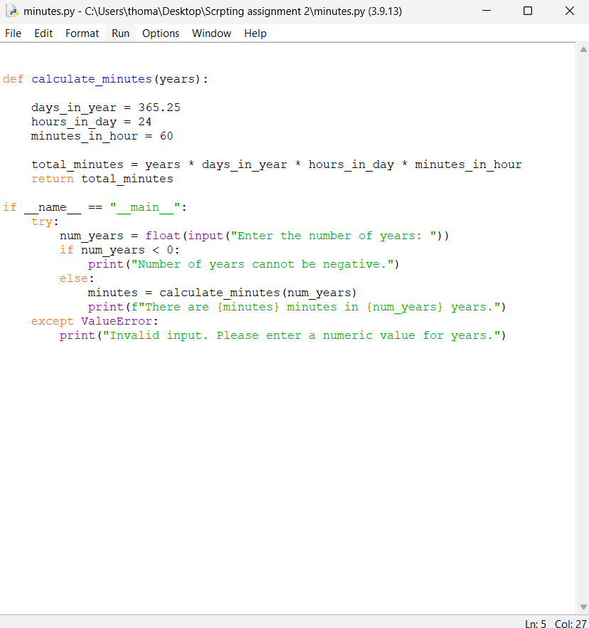

**The code in action.**

**Project 10**

**The code**

